Brian Dekker

Brian.dekker@hva.nl

Function apps

Summary azure function apps

Inhoud

# Function apps.

Azure functions is a serverless service that allows you to write less code and maintain less infrastructure. With function apps all you need to worry about is the code everything else is handled by azure functions.

Often we build systems that react to certain events. This can be something in a web app, database, queues and so on. Almost always in every application code needs to trigger whenever a certain event occurs.

Azure function can do this for you by using “Compute on demand”.

## Example Scenario’s

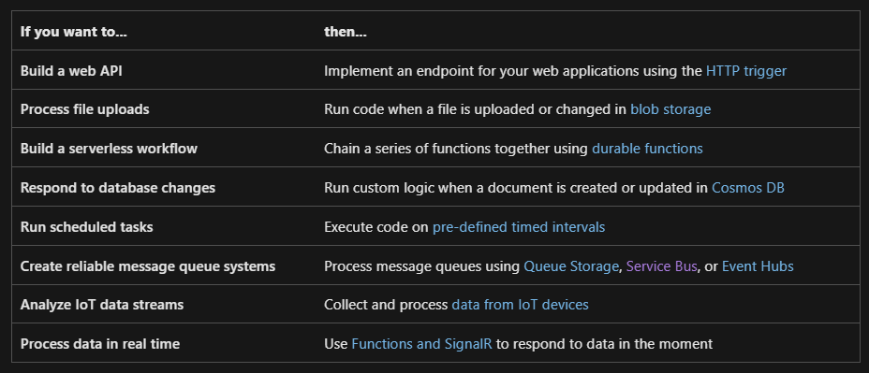

## Function Code.

A *function* is the primary concept in Azure Functions. A function contains two files:

* File containing the code
* Function.json a config file

The function.json defines the function’s trigger, bindings and other configuration settings. Every function has only one trigger but can have multiple in and out bindings. The runtime uses this config file to determine the events to monitor and how to pass and return data from a function execution. Here is are two example of a function.json file one is a concept the other one I use:

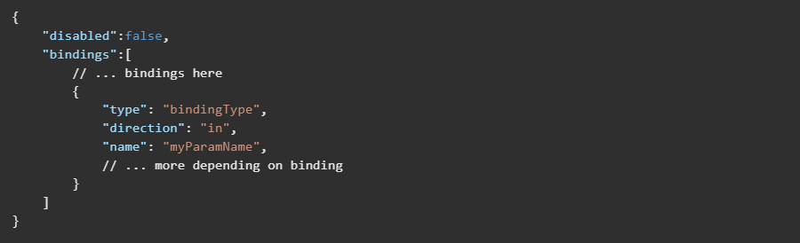

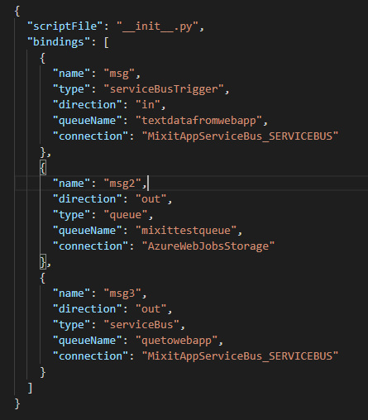

The bindings property is where you configure both triggers and bindings. Each individual binding has a few propertys in common these are:

* Type: Type of binding for example serviceBus or serviceBusTrigger
* Direction: Indicates whether the binding is receiving or sending data.
* Name : The name that is used in the code file when calling the binding.